JECRC
JAIPUR

INDIVIDUAL Lab Instructor DATA SHEET 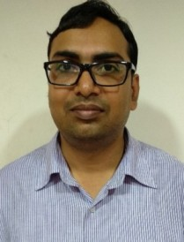
Name of the Lab Instructor | : | Amit Jain
Present Designation | : | Lab Instructor
Email Id: amitjain6879@gmail.com
Contact Details: 9314088836

I. Particulars of Educational Qualification: (only completed)

Category | Name of the Degree | Specialization | Year of Passing | Name of the College | Name of the University
UG | B.A | ARTS | 2006 | PVT. | RAJASTHAN UNIVERSITY
DIPLOMA | DIPLOMA | ELECTRONICS | 2000 | KHAITAN POLYTECHNIC COLLEGE JAIPUR | BTER JODHPUR [RAJ]

II. Academic Experience : 16Y

III. Industrial Experience : NIL

IV. Awards/Achievements :

VI. Research/Specialization :

VII. Course Taught :

